**Allocution  
of the   
Most Illustrious Commander-in-Chief  
 and  
Deputy for the Orient of Ohio**

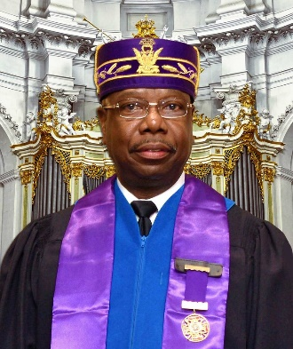

**October 22, 2022**

“Walk in wisdom toward them that are without, redeeming the time. Let your speech be always with grace, seasoned with salt, that ye may know how ye ought to answer every man.”—Colossians 4:5–6 KJV

To the 20th Sovereign Grand Commander of the United Supreme Council, Ancient & Accepted Scottish Rite of Freemasonry, P.H.A., Northern Jurisdiction, USA, Inc., the Honorable Dr. Melvin J. Bazemore 33° represented by Lieutenant Grand Commander S.G.I.G. Sidney D. Broadnax Jr. 33°; to the 65th Most Worshipful Grand Master of the Most Worshipful Prince Hall Grand Lodge of Ohio, the Honorable Jerry R. Ellerson 33° and his Trustees; to the Assistant to the Deputy for the Orient of Ohio S.G.I.G. Louis C. Crocheron 33º; to the Sovereign Grand Inspectors General; to the officers of the Ohio Council of Deliberation; to the Grand Inspectors General; to all past and present Illustrious Commanders-in-Chief; to all Sublime Princes; and to all our distinguished guests…

Good morning.

**Intro**

Before any important undertaking we should invoke the blessings of Deity.

♦ ♦ ♦

I would first like to thank my Creator and Lord and Savior Jesus Christ for His divine intervention for allowing me the strength and spirit to represent this Ohio Council of Deliberation for another year. I would also like to give thanks to Cheryl Williams, the First Lady of the Orient of Ohio, along with our daughters and grandchildren. Without their support there would be no joy in this labor of love that I have for this organization.

I would like to take this opportunity to thank our Sovereign Grand Commander, the Honorable Dr. Melvin J. Bazemore 33º

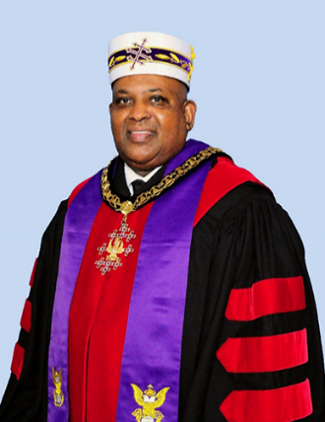

for his extraordinary leadership and for having the confidence to allow me to continue to be his representative serving as the Most Illustrious Commander-in-Chief and Deputy for this great Orient. I humbly and proudly serve to the best of my ability.

The efforts exuded by L.D. Easton Consistory No. 21 and Capital Valley Assembly No. 36 are to be recognized. This 113th Annual Session is the first to be held in person in 2 years. The playing field has changed a bit in that time.

The officers of the Ohio Council of Deliberations and the Ohio Commanders of the Rite deserve my gratitude as well.

**Necrology**

Much to our chagrin the bell constantly tolls. We can only hope that it has not tolled for anyone we know. In the case of last year, we were not that fortunate. The Council of Deliberation of Heaven has gained a few more Fraters and Loyal Ladies; notably S.G.I.G. Charles E. “Chuck” Richardson 33° of Bezaleel Consistory No. 15 and PSGLLRs LL Geraldine Kelley and LL Donna Austin both of Capital Valley Assembly No. 36.

**State of the Nation**

Just when we thought we might have been out of the woods and getting a handle on the coronavirus pandemic, the Delta and Omicron variants surfaced with a vengeance. However, the COVID-19 pandemic has subsided to manageable levels across the country as herd immunity has reached sufficient levels in the population. I still encourage everyone to get their shots and/or boosters; wear your masks; and take appropriate measures. Just as we thought we were in the clear with widespread infectious diseases, monkeypox befalls us! However, that has proven not to be as impactful as coronavirus for which we are all grateful.

The price of consumables (gas and food) have reached highs not experienced in some time. Gun violence is an ever-present epidemic. This was painfully demonstrated through the deadly mass shooting in Buffalo where victims were targeted and killed solely due to the color of their skin. I implore you to remain vigilant. If you see something, say something!

Following that somber note is a much better one. I am happy to report that for the first time in more than 20 years the United States is not involved in major armed conflict although the Congress is giving boatloads of money to the Ukraine instead of tackling issues of far greater importance here on the home front.

Another glass ceiling was shattered when Judge Kentaji Brown Jackson was nominated, confirmed, and sworn into office as the first Black woman to be an Associate Justice of the U.S. Supreme Court.

Speaking of the Supreme Court, as we have been witness to one of the most volatile and jaw-dropping eras of politics in recent memory, it goes to illustrate the importance of voting. Certain decisions could not have been reversed if those naysayers who *do not* vote *actually did vote* in the presidential election of 2016.

The previous occupant of the White House is still making noise well into the term of the current President. This is proof that if you do not clean completely, the smell will linger on indefinitely. That brings me to my next point.

I must impress upon you that Election Day is just around the corner. When you wear the robe, you do not talk “party”; you talk “issues.” It is so very important that you know and understand the issues and vote your conscience. Nowadays the only disenfranchisement is that you do to yourselves by *not* intelligently exercising your right to VOTE!

**State of the Rite**

It is the Sovereign Grand Commander’s stated preference to maintain a high level of engagement throughout the ranks. Even through the ever-present COVID pandemic he sought to truly illustrate that “Communication is the currency of the realm.” Through use of the Constant Contact email platform; the USC NJ website; USC NJ Facebook page; and communications from the Cathedral trickled down through the Deputies, the membership has remained informed.

The Loyal Ladies have enjoyed a renewed focus through the pointed involvement of the Sovereign Grand Commander and the creation of the Order of the Golden Circle Working Group, and they are loving it! All Loyal Ladies are invited to contribute their thoughts and experiences to the *The Dove & The Quill* (the upcoming sister publication to *Scottish Rite Reflections).* It is said behind (or alongside) every good man is an even better woman.

Our United Supreme Council is enjoying a robust period of fraternal relations with our participation in the Statement of Unity signing signaling to the greater masonic world that there exist *only* four (4) legitimate Scottish Rite organizations in these United States. That ceremony was augmented by the news that we will soon enjoy recognition and visitation with the Supreme Council of Canada pending ratification of the agreement at our next Annual Session.

There is a lot to look forward to and it is safe to say the State of the Rite is strong.

**State of the Orient**

Due to COVID-19 the previous two Annual Sessions were held virtually. I am certainly glad to be able to address you all in person this time.

In December 2021, S.G.I.G. Steve Reese Sr. 33° was honored in a street naming ceremony. In recognition of this honor, I declared Monday, December 13, 2021, as “Dr. Steve Reese Sr. Day” throughout the Orient of Ohio.

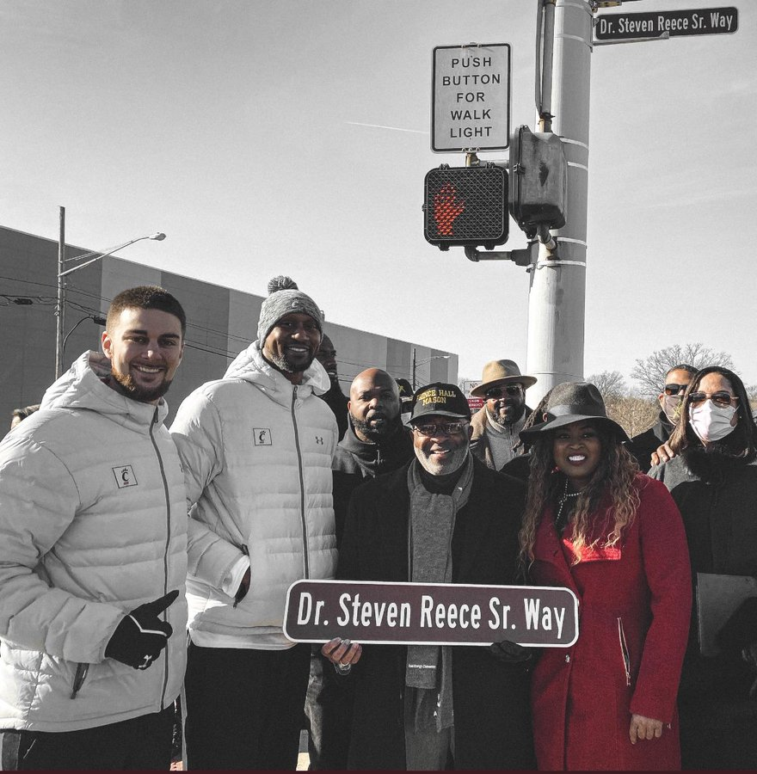

*Raffle*

New to our Orient was a statewide raffle conducted last fall. G.I.G. Sean P. Ruffin 33° led the charge on this endeavor. All Consistories and Assemblies received tickets, and the total allotment was sold. The drawing was held on Saturday, December 18, 2021, and the winners were announced.

We are running the raffle again this year. Tickets are 1 for $2 or 3 for $5. Please see your point of contact in your Consistories or you can buy some tickets at this Council of Deliberation.

*Testimonial*

On April 23, Bezaleel Consistory No. 15 saw fit to honor me with a testimonial dinner and for that I am eternally grateful. There had not been a testimonial for a Deputy for the Orient of Ohio in 16 years. The event was attended by a wide array of the Prince Hall family membership to include Sovereign Grand Commander Dr. Melvin J. Bazemore 33°; the Most Worshipful Grand Master of the Most Worshipful Prince Hall Grand Lodge of Ohio, Jerry R. Ellerson; and other masonic luminaries.

The highlight of it all for me was the very moving tribute to my late mother Lula Belle Williams performed by G.I.G Prester Pickett 33° and LL Bertha Pickett. I will take this time to thank you all for attending.

*Honorary doctorate*

On Saturday, May 7, 2022, the Orient of Ohio was privileged to bear witness to another Sovereign Grand Commander acknowledged due to his body of work. The Board of Trustees of Wilberforce University saw fit to confer an honorary Doctorate of Humane Letters upon Sovereign Grand Commander Melvin J. Bazemore 33°. Commander Bazemore is the third of our leaders to enjoy the privilege and honor of being conferred an honorary doctorate from Wilberforce University. Sovereign Grand Commander Solomon Wallace 33° (2012) and one of Ohio’s own, Sovereign Grand Commander Samuel Brogdon Jr. 33° (2000) preceded him. The United Supreme Council has a long history of financially supporting the education of college students at Wilberforce University through our Benevolent Foundation as does the Orient of Ohio.

*Inspections*

I have performed virtual inspections of all five Consistories and all five Assemblies. All the fiscal books of the respective officers are sound and will survive an audit. The equipment is in good condition, and the works of the Rite are performed adequately. All bodies have met their obligation to the Orient of Ohio and our United Supreme Council. I want to thank all the officers of the various Consistories and Assemblies for the courtesies extended to me this past year.

*Scholarships*

The listing of scholarships awarded by our Council of Deliberation is included in the book of reports. The members of our Council of Deliberation continue Ohio’s strong tradition of masonic philanthropy ensuring that future generations have a decent beginning to their college careers free or partially free from the financial burden often incurred in order to progress. This year we have awarded more than $22,000 to 32 worthy students.

We must ensure that our scholarship funds remain generously funded and our students phenomenally resourced. Between the MWPHGL of Ohio, Ohio Council of Deliberation, and the United Supreme Council I know the framework is in place for their success.

The Ohio Council of Deliberation has awarded more than 500 scholarships totaling in excess of $450,000 throughout the past 50-plus years and we look forward to many more!

*Mentoring program*

The specter of COVID–19 severely impacted normal in-person schooling which affected our ability to mentor to those affected students. We hope that we can resume our efforts with minimal interruption this fall.

*Website*

Visit [www.orientofohiopha.org](http://www.orientofohiopha.org). Through the efforts of the website development team, we have a first-class product, and we own one of only seven (7) COD websites in the jurisdiction. Response to the website has been positive and encouraging. Please continue to check it for news and information.

I am also proud to announce that Bezaleel Consistory will have the first website for a Consistory in the Orient of Ohio. Construction is almost completed.

*Commanders of the Rite*

Led by S.G.I.G. Gregory S. Snead 33°, the Ohio Commanders of the Rite remains on a steady course. A favorable report was received from all Valleys.

Polo shirt sales are still ongoing. The polo shirt is a joint venture between the Ohio Commanders of the Rite and the Ohio Council of Deliberation. Please note that a rebate of $5 for the Council of Deliberation; $5 for the Ohio Commanders of the Rite; and $5 for the Consistory to which the Frater belongs is included in the price. This is a winning situation for all involved!

Please keep in mind that ALL Sovereign and Grand Inspectors General are members of the Commanders of the Rite. It is up to the Valley Secretaries to collect the dues. Valley Secretaries please ensure all 33rd degree members in your Consistory pay their dues. It is disheartening to hear the reports of the Valley Vice Presidents indicating there are *X* number of Grand Inspectors General in their Valleys, but only *Y* number of Grand Inspectors General are dues-paying members.

*Order of the Golden Circle*

Per the Sovereign Grand Commander, the edict remains in effect that all women who are members of the Order of the Eastern Star and the Heroines of Jericho, may join the Order of the Golden Circle. Please encourage the eligible ladies in your life (mothers, sisters, wives, *etc*.) who are not members to pursue membership. Just so there is a complete understanding and no ambiguity, female relatives are able to join the Order of the Golden Circle **without** first joining the Order of the Eastern Star due to the temporary suspension of bloodline requirement to join the Order of the Eastern Star in some of our jurisdictions.

*Fraternal Relations*

The Orient of Ohio remains in lockstep with the Most Worshipful Prince Hall Grand Lodge of Ohio, and we strive to have no daylight between us.

The Orient of Ohio maintains excellent relationships with the Most Excellent Prince Hall Grand Chapter of Ohio Royal Arch Masons; Most Illustrious Prince Hall Grand Council of Royal and Select Masters; Prince Hall Grand Commandery, Knights Templar, State of Ohio; Desert of Ohio; and the AEAONMS. Furthermore, we have synergized efforts with the Most Worshipful Prince Hall Grand Lodge of Ohio and the Desert of Ohio as it relates to voter awareness efforts under the leadership of Illustrious Joseph Clark Jr.

In March, Western Consistory No. 28, Valley of Chicago, Orient of Illinois honored Sovereign Grand Commander Melvin J. Bazemore 33° with the Visionary Leadership Award during a banquet held for that purpose. It was well attended. I thoroughly enjoyed myself.

Regrettably I was unable to attend our counterpart Ohio Council of Deliberation Annual Session in June, but S.G.I.G. Wilton E. Blake I 33° represented me and our Council of Deliberation very well.

At the end of August, I attended the third Annual Pennsylvania Commanders of the Rite banquet. It honored three current and one past Cabinet member of the United Supreme Council.

From September 28 to October 4, I was in Denver, Colorado for Colorado’s Council of Deliberation. I attended while performing a site inspection at the host hotel for next year’s USC Annual Session.

I also attended the United Supreme Council, Southern Jurisdiction in Jacksonville, Florida from October 7 through October 11.

As you can tell, the Scottish Rite of Freemasonry is alive and well in the Orient of Ohio and the state of the Orient is strong.

**United Supreme Council**

*Annual Session*

The 141st Annual Session was held in the Holy See of Philadelphia. The highlight of the triennial meeting was the election. Sovereign Grand Commander Bazemore was re-elected to another 3-year term and his officers were as well including Ohio’s own S.G.I.G. Sidney D. Broadnax Jr. 33°, Lieutenant Grand Commander.

*Class*

The first Class to be Elevated in person since the coronavirus impacted our regular lives was named the *Samuel J.D. Shook Jr. Class of 2022*. **“SHOOK TIME!”** was in full effect. Illustrious Shook was the beloved Class instructor for more than1,600 Grand Inspectors General during a 17-year tenure.

Illustrious Shook was a long-time member of Saginaw Valley Consistory No. 41 in the Orient of Michigan. There are 92 Fraters in the Class of which 12 are members of the Orient of Ohio.

The Orient of Ohio was the beneficiary of one more addition to the executive ranks. G.I.G. Dr. C. Keith Melvin 33° was reclassified as a Sovereign Grand Inspector General of the Emeritus grade due to his participation in the Medical Department. Please keep in mind it is becoming increasingly more difficult to move to the next level. What you do and how you support is being closely monitored.

*Street renaming*

On Saturday of the Annual Session the honorary street renaming of the 1500 block of Fitzwater Street to “United Supreme Council Way” occurred. This idea was proposed by S.G.I.G. Reginald B. Stewart 33°, and it was a success. Sovereign Grand Commander Corey D. Hawkins Sr., Esq. 33°, Southern Jurisdiction and Sovereign Grand Commander Gaetan Mentor 33°, Supreme Council of Haiti, as well as the *Samuel J.D. Shook Jr. Class of 2022* were in attendance to witness this special occasion.

The street renaming was followed by a health fair sponsored by Independence Blue Cross.

*Allocution*

Commander Bazemore delivered a motivational, inspirational, and informative allocution covering the last year of activity of the United Supreme Council. Highlights included—

* creation of an Education department;
* Sublime Princes being allowed to attend Annual Session;
* creation of the Orient of the Caribbean;
* the successful rollout of the Lifetime Membership program;
* the successes of the Veterans Committee; and
* many other successes among a long list of initiatives of enhancement.

Apart from the Allocution, Commander Bazemore bestowed honorary membership upon Sovereign Grand Commander Corey D. Hawkins Sr. 33°; Sovereign Grand Commander Peter J. Samiec 33°; Sovereign Grand Commander James D. Cole 33°; and Sovereign Grand Commander Gaetan Mentor 33°.

*Banquet*

As one of the three highlights of the weekend, the banquet was robustly attended by all. The Orient of Ohio was represented at the highest level through the awarding of the Gold Medal of Achievement to myself for 2020; Illustrious Grand Prior S.G.I.G. Wilton E. Blake I 33° for 2020; and S.G.I.G. Dr. Steven Reese Sr. 33° for 2022.

For the first time in recent history, Loyal Ladies were recognized with an award during the banquet.

Initiatives

*Lifetime membership*

The lifetime membership program for the United Supreme Council was launched and the Charter Class of 2021 has been filled. The window of opportunity has now closed. The program was well‑received program and raised almost $600,000 to ensure the future financial stability of our United Supreme Council.

To the 12 members of the Orient that participated I thank you for your support.

For those who need a bit more information and those who wish to participate during the next open window please keep in mind that each Lifetime Membership creates a small-scale endowment for that member with their dues being paid into perpetuity even after the member is deceased thereby creating a “legacy.” The cost to participate the next year, as mentioned in the Sovereign Grand Commander’s Allocution, has been set at $2,800.

*Raffle*

The Annual Fundraising Subcommittee’s second raffle ticket event proved to be very successful. Of the seven prizes one winner was from Ohio (PSGLLR Joyce Aldridge).

Congratulations are in order for G.I.G. Gregory Allen 33° for his excellent leadership. He raised more $16,000 during the last 2 years.

*Scottish Rite Reflections*

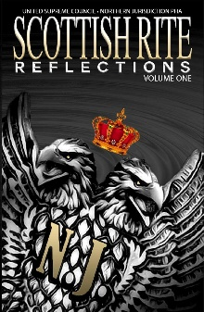

Volume 2 of this series was released in June to rave reviews. Once again, Fraters from the Orient of Ohio contributed mightily to and assisted with ensuring this educational offering was a success. Please congratulate the following as they are now published writers—S.G.I.G. Reginald B. Stewart 33°; G.I.G. Maurio D. Powell 33°; G.I.G. Roderick Q. “Rodney” Blount 33°; and G.I.G. Samuel E. Lindsey 33° on their inclusion. Please note that this volume is dedicated to the memory of S.G.I.G. Charles W. “Charlie” Hales 33°. The first entry is a tribute to Illustrious Hales which I had the honor to write.

*Walk of Fame Brick Paver Program*

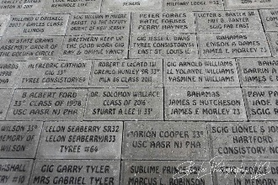

There is still room available in the Walk of Fame Garden at the Cathedral. You will find the form on the Council of Deliberation website. Phase 1 and 2 of the project have been completed and Phase 3 is now ongoing.

The Orient of Ohio was represented in large numbers during both phases of the project, and I thank the Fraters and Loyal Ladies of the Orient of Ohio for participating.

When I was Most Worshipful Grand Master, I had a saying: “Grand Lodge officers support Grand Lodge programs.” Well, here I am saying it again with a little twist: “Scottish Rite Masons support Scottish Rite programs.” Support is paramount to success.

Also please be advised you may stay abreast of the happenings of our United Supreme Council thought the website, [www.uscnjpha.org](http://www.uscnjpha.org) and on Facebook at “The United Supreme Council - AASR - PHA - Northern Jurisdiction USA, Inc.”

**For the Good of the Order**

Fraters, please submit newsworthy articles to the United Supreme Council’s *Bulletin*. It is printed twice yearly—spring and fall. All articles must be sent through me. Also, please submit articles to the Grand Lodge’s *Lamp*. Spread the good news of Scottish Rite freemasonry and its members!

**Recommendations**

It is my recommendation that the Orient of Ohio—Consistories and Assemblies—continue to comply with all directives issued from the United Supreme Council, the Sovereign Grand Commander, and the Most Illustrious Commander-in-Chief and Deputy for the Orient.

*Honorary members*

It is my recommendation that S.G.I.G Samuel King 33° (Orient of Pennsylvania) be made an honorary member of the Ohio Council of Deliberation.

*Donations*

It is my recommendation that $1,000 be donated to the United Supreme Council’s Benevolent Fund on behalf of the Ohio Council of Deliberation.

It is my recommendation that $250 be donated to the Grand Lodge’s *Lamp*.

*Awards*

It is my recommendation that G.I.G. H. Daryl Melvin 33° be awarded the MeritoriousServiceAward*.*

**Conclusion**

I have now arrived at the end of another allocution. The time for reflection is upon us once again.

Things to remember—

* Your obligation binds you to the degree; your Oath of Fealty binds you to the organization.
* Be careful what you ask for. You may get appointed and become disappointed.
* If you do not major in management, you will minor in damagement.
* It is an embarrassment in today’s day and age to be willfully ignorant. Seek the knowledge you wish to attain.
* There is a difference between being used and being useful.
* Do not confuse sufficiency with efficiency. At this juncture in Scottish Rite freemasonry, it becomes a skill v. will issue: Do you know how to do it and if so, will you do it?

With that in mind, aim to be productive and not destructive. Take heed to the lessons inculcated in the 15th degree and the implements used therein—the sword and the trowel. Both are implements that can be used to build or destroy. The onus is on the possessor of said implement to decide when and for what purpose either will be used. The trowel can be used to spread the mortar connecting the stones that compose the walls of the castle while the sword is outside defending the castle, kingdom, and its people from undue harm. The trowel also spreads the cement of brotherly love and affection after the sword has swung in defense. Allegorically, which do you choose?

The practical application of basic common sense will help you avoid the trap of demanding much, explaining little, and apologizing never.

Fraternally,



Most Illustrious Commander-in-Chief   
and Deputy for the Orient of Ohio

**OFFICIAL ACTS AND VISITATIONS**

**October 23–24, 2021** Presided, 112th Annual Ohio Council of Deliberation, VIRTUAL

**October 24, 2021** Attended, 50th Annual Ohio Grand Assembly, VIRTUAL

⸎

**November 10, 2021** Attended 38th Annual Conference, NCBMP, Hyatt Regency Cincinnati, Cincinnati, Ohio

**November 12–13, 2021** Attended Recognition Banquet, 65th Most Worshipful Grand Master Jerry R. Ellerson, Holiday Inn Cleveland South, Independence, Ohio

**November 17, 2021** Attended meeting, Bezaleel Consistory No. 15, VIRTUAL

⸎

**December 15, 2021** Attended meeting/virtual Reunion, Bezaleel Consistory No. 15, VIRTUAL

**December 19, 2021** Attended St. John the Evangelist Day celebration,  
7th Masonic District, VIRTUAL

**December** **19, 2021** Attended Zoom Gospel Fest, 60th Anniversary, Dove Assembly No. 34, VIRTUAL

**December 25, 2021** Attended Christmas Observance, Emmanuel Commandery No. 32, VIRTUAL

**December 30, 2021** Attended masonic service, Brother Richard “Doc” Holiday, Watson’s Funeral Home, Cleveland, Ohio

⸎

**January 13–15, 2022** Attended Deputy Conference, United Supreme Council, Omaha, Nebraska

**January 19, 2022** Attended elections, Bezaleel Consistory No. 15 / Bezaleel Assembly No. 19, VIRTUAL

**January 19, 2022** Attended elections, Dove Assembly No. 34, VIRTUAL

**January 26, 2022** Participated, Sovereign Grand Inspectors General teleconference

**January 27, 2022** Participated, Grand Inspectors General teleconference

⸎

**February 5, 2022** Attended meeting, Miami Consistory No. 26, VIRTUAL

**February 16, 2022** Attended meeting, Bezaleel Consistory No. 15, VIRTUAL

⸎

**March 16, 2022** Attended meeting, Bezaleel Consistory No. 15, VIRTUAL

**March 17, 2022** Attended Ceremony of Remembrance and Renewal, VIRTUAL

**March 26, 2022** Attended banquet honoring Sovereign Grand Commander Melvin J. Bazemore 33°, Medina Temple, Addison, Illinois

**March 29, 2022** Participated, Sovereign Grand Inspectors General teleconference

**March 30, 2022** Participated, Grand Inspectors General teleconference

⸎

**April 1–3, 2022** Attended Grand Worthy Matron Recognition Banquet, “A Prestigious Moment,” Radisson Dayton Hotel, Dayton, Ohio

**April 13–15, 2022** Attended corporate meetings, United Supreme Council, Northern Jurisdiction, VIRTUAL

**April** **20,** **2022** Attended meeting Bezaleel Consistory No. 15 / Bezaleel Assembly No. 19, El Hasa Temple, Cleveland, Ohio

**April 22–24, 2022** Honoree, Testimonial Weekend, Holiday Inn Independence, Independence, Ohio

⸎

**May 14, 2022** Attended civil service, G.I.G. Edward W. Miles 33°, Canaan Missionary Baptist Church, Cleveland, Ohio

**May 18, 2022** Attended meeting, Bezaleel Consistory No. 15, El Hasa Temple, Cleveland, Ohio

**May 24–May 31, 2022** Attended 141th Annual Session, United Supreme Council, Ancient and Accepted Scottish Rite of Freemasonry, Prince Hall Affiliation, Northern Jurisdiction, USA, Inc., Downtown Philadelphia Marriott, Philadelphia, Pennsylvania

⸎

**June 3–5, 2022** Attended Midwest Regional Gala Days, Cleveland Marriott East, Warrensville Heights, Ohio

**June 10–12, 2022** Attended Grand Worthy Patron Recognition Banquet, “Make a Change,” DoubleTree by Hilton Hotel Westlake, Westlake, Ohio

**June 12, 2022** Attended Whit Sunday program, VIRTUAL

**June 15, 2022** Attended meeting, Bezaleel Consistory No. 15, El Hasa Temple, Cleveland, Ohio

**June 19, 2022** Inspected La Paz Assembly No. 35, Toledo, Ohio

**June 26, 2022** Attended Seventh Masonic District St. John the Baptist Day observance, St. John AME Church, Cleveland, Ohio

⸎

**July 20, 2022** Attended meeting, Bezaleel Consistory No. 15, El Hasa Temple, Cleveland, Ohio

⸎

**August 6–9, 2022** Attended 172nd Annual Communication, Most Worshipful Prince Hall Grand Lodge of Ohio, Renaissance Hotel, Cleveland, Ohio

**August 12–18, 2022** Attended 129th Annual Session, Ancient Egyptian Arabic Order Nobles Mystic Shrine of North and South America, Inc., Downtown Philadelphia Marriott, St. Louis, Missouri

**August 27, 2022** Attended 3rd Annual Banquet, Pennsylvania Commanders of the Rite, Crowne Plaza Hotel, King of Prussia, Pennsylvania

⸎

**September 11, 2022** Attended Prince Hall Americanism Day services, Mt. Zion Congregational Church, Cleveland, Ohio

**September 18, 2022** Attended,Cleveland Commanders of the Ritemeeting,Home of G.I.G. Maurice Hereford 33°, Lyndhurst, Ohio

**September 21, 2022** Attended meeting, Bezaleel Consistory No. 15 / Bezaleel Assembly No. 19, El Hasa Temple, Cleveland, Ohio

**September 28–October 4, 2022** Attended Colorado, Wyoming, and Utah Council of Deliberation/site inspection, Denver, Colorado

**October 6–11, 2022** Attended 136th Annual Session, United Supreme Council, Ancient and Accepted Scottish Rite of Freemasonry, Prince Hall Affiliation, Southern Jurisdiction, USA, Inc., Hyatt Regency Jacksonville, Jacksonville, Florida

**October 14–15, 2022** Attended masonic and civil service, G.I.G. Harold R. Wilson 33°, Calhoun Funeral Home, Bedford Heights, Ohio

**PROCLAMATIONS**

CAW 4–21 Dr. Steven Reese Sr. Day  
December 13, 2021

CAW 1–22 Observance of Renewal and Remembrance  
March 17, 2022

CAW 2–22 Observance of Whit Sunday  
May 23, 2021

CAW 3–22 113th Annual Session, Ohio Council of Deliberation/51st Annual Session, Ohio Grand Assembly  
October 21–23, 2022

**DIRECTIVES**

Resumption of virtual meetings  
December 13, 2021

Resumption of in-person meetings  
March 4, 2022