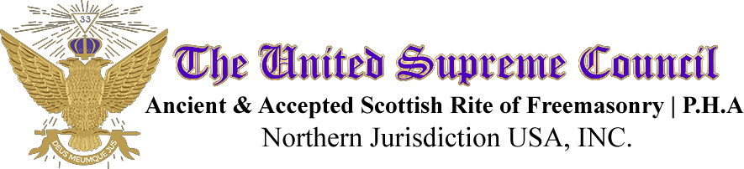

S.G.I.G. CARL A. WILLIAMS #15 Most Illustrious Commander-In-Chief
Deputy for the Orient of Ohio Ohio Council of Deliberation
4201 Stilmore Road South Euclid, Ohio 44121 Phone: (216) 382-3358
V-Mail: (216) 850-4469
E-Mail: mrcarlanwilliams@aol.com

PROCLAMATION-CAW 2-26
Whit Sunday

TO: Officers and Members of the Ohio Council of Deliberation; State Grand Loyal Lady Ruler, Officers and Members of the Ohio Grand Assembly; Sovereign and Grand Inspectors General; Illustrious Commanders-in-Chief (Present and Past); Loyal Lady Rulers, Officers, and Loyal Ladies; Knight Commanders; and Sublime Princes.

GREETINGS,

In keeping with our Ancient Tradition adopted by the Ancient and Accepted Scottish Rite of Freemasonry, Prince Hall Affiliation, N.J., USA Inc. we will pay tribute to Whit Sunday, which will be held Sunday, June 7, 2026.

Therefore, by the virtue of the power and authority vested in me as Deputy for the Orient of Ohio, know ye that I, Carl A. Williams, do hereby proclaim to all Fraters and Loyal Ladies owing allegiance to this Orient, that Whit Sunday, shall be solemnly observed on Sunday, June 7, 2026.

This Proclamation must be read at all meetings prior to Whit Sunday
Take due notice and govern yourself accordingly. Given under my hand and seal as Deputy for the Orient of Ohio of the United Supreme Council, A.A.S.R., P.H.A. Northern Jurisdiction, U.S.A., Inc. and Most Illustrious Commander-in-Chief of the Ohio Council of Deliberation at Cleveland, Ohio this 5th day of February 2026.

Fraternally,
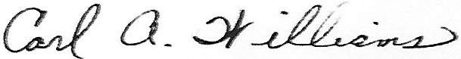
S.G.I.G. Carl A.Williams 33°
Deputy for the Orient of Ohio

